**ECEN5623, Real-Time Embedded Systems:**

**Exercise #1 – Invariant LCM Schedules**

DUE: As Indicated on Canvas and in class

Please thoroughly read Chapters 1 & 2 in the text

Please see example code provided on Canvas

***Note: You must run any code that uses SCHED_FIFO, real-time priority, using “sudo”***

**Exercise #1 Requirements**:

1. [20 points] The Rate Monotonic Policy states that services which share a CPU core should multiplex it (with context switches that preempt and dispatch tasks) based on priority, where highest priority is assigned to the most frequently requested service and lowest priority is assigned to the least frequently requested AND total shared CPU core utilization must preserve some margin (not be fully utilized or overloaded). Draw a timing diagram for three services S1, S2, and S3 with T1=3, C1=1, T2=5, C2=2, T3=15, C3=3 where all times are in milliseconds. [Note that you can find examples of timing diagrams in Lecture and [here](http://mercury.pr.erau.edu/~siewerts/cec450/documents/Timing_Diagrams/) and in Canvas – note that we have not yet covered dynamic priorities, just RM fixed policy described here, so ignore EDF and LLF for now]. Label your diagram carefully and describe whether you think the schedule is feasible (mathematically repeatable as an invariant indefinitely) and safe (unlikely to ever miss a deadline). What is the total CPU utilization by the three services?
2. [20 points] Read through the Apollo 11 Lunar lander computer overload story as reported in RTECS Notes, based on this [NASA account](https://www.hq.nasa.gov/alsj/a11/a11.1201-pa.html), and the descriptions of the 1201/1202 events described by [chief software engineer Margaret Hamilton](https://en.wikipedia.org/wiki/Margaret_Hamilton_%28scientist%29) as recounted by [Dylan Matthews](http://www.vox.com/2015/5/30/8689481/margaret-hamilton-apollo-software). Summarize the story. What was the root cause of the overload and why did it violate Rate Monotonic policy? Now, read [Liu and Layland’s paper](http://mercury.pr.erau.edu/~siewerts/cec450/documents/Papers/liu_layland.pdf) which describes Rate Monotonic policy and the Least Upper Bound – they derive an equation which advises margin of approximately 30% of the total CPU as the number of services sharing a single CPU core increases. Plot this Least Upper bound as a function of number of services and describe 3 key assumptions they make and document 3 or more aspects of their fixed priority LUB derivation that you don’t understand. Would RM analysis have prevented the Apollo 11 1201/1202 errors and potential mission abort? Why or why not?
3. [20 points] Download <http://mercury.pr.erau.edu/~siewerts/cec450/code/RT-Clock/> and build it on the Altera DE1-SOC, TIVA or Jetson board and execute the code. Describe what it’s doing and make sure you understand clock_gettime and how to use it to time code execution (print or log timestamps between two points in your code). Most RTOS vendors brag about three things: 1) Low Interrupt handler latency, 2) Low Context switch time and 3) Stable timer services where interval timer interrupts, timeouts, and knowledge of relative time has low jitter and drift. Why are each important? Do you believe the accuracy provided by the example RT-Clock code?
4. [40 points] This is a challenging problem that requires you to learn a bit about pthreads in Linux and to implement a schedule that is predictable. Download, build and run code in the following three example programs: 1) simplethread, 2) rt_simplethread, and 3) rt_thread_improved and briefly describe each and output produced. [Note that for real-time scheduling, you must run any SCHED_FIFO policy threaded application with “sudo” – do man sudo if you don’t know what this is]. Based on the examples for creation of 2 threads provided by incdecthread/pthread.c, as well as testdigest.c with use of SCHED_FIFO and sem_post and sem_wait as well as reading of POSIX manual pages as needed - describe how you would attempt to implement Linux code to replicate the LCM invariant schedule implemented in the [VxWorks RTOS](http://mercury.pr.erau.edu/~siewerts/cec450/code/VxWorks-sequencers/lab1.c) which produces the schedule measured using event analysis shown below:

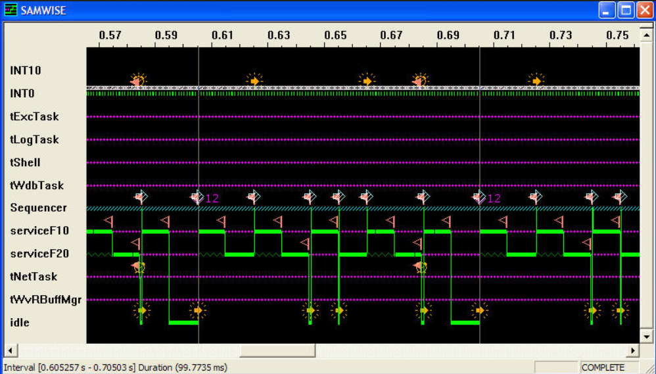

The observed timing above fits our theory for RM policy on a priority preemptive scheduling system as shown by the timing diagram below:

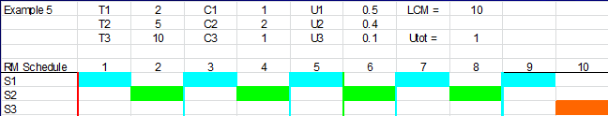

You description should outline how you would implement code equivalent to the VxWorks synthetic load generation and schedule emulator. Code the Fib10 and Fib20 synthetic load generation and work to adjust iterations to see if you can at least produce a reliable 10 millisecond and 20 millisecond load on a Virtual Machine, or on the Jetson, Altera or TIVA system (they are preferred and should result in more reliable results). Describe whether your able to achieve predictable reliable results in terms of the C (CPU time) values alone and how you would sequence execution.

Hints – You will find the [LLNL (Lawrence Livermore National Labs) pages on pthreads](https://computing.llnl.gov/tutorials/pthreads/) to be quite helpful.

If you really get stuck, a detailed solution and analysis can be found [here](http://ecee.colorado.edu/~ecen5623/ecen/labs/Linux/IS/Report.pdf) and on Canvas, but if you use it, be sure to cite it and make sure you understand it and can describe it well. If you use this resource, note how similar or dissimilar it is to the original VxWorks code and how predictable it is by comparison.

**Grading Rubric**

[20 points] Rate Monotonic Analysis and Timing Diagrams:

[10 points] Correct diagram ____________________________________

[5 points] Feasibility and safety issues articulated ___________________

[5 points] Utility and method description __________________________

[20 points] Shared CPU system overload:

[5 pts] Apollo 11 reading and summary ____________________________

[5 pts] Root cause analysis and description __________________________

[5 pts] RM LUB plot and description of margin ______________________

[5 pts] Arguments for and against RM policy and analysis prevention of Apollo 11 overload scenario (at least 2 main arguments and points) ____________________

[20 points] POSIX Real-Time Clock:

[5 pts] Download, build, run as is ____________________________________

[5 pts] Description of code as is ______________________________________

[5 pts] What is value of each RTOS bragging point? ______________________

[5 pts] Determination and argument for or against accuracy of RT clock on system tested ________________________________________________________________

[40 points] Pthread download, build, and analysis of features:

[5 pts] Download, build, run simple thread code___________________________

[5 pts] Download, build, run example-sync code ___________________________

[15 pts] Description of key RTOS / Linux OS porting requirements ____________

(5 pts) Threading vs. tasking _____________________________________

(5 pts) Semaphores, wait and sync _________________________________

(5 pts) Synthetic workload generation ______________________________

[10 pts] Synthetic workload analysis and adjustment on test system _____________

[5 pts] Overall good description of challenges and test/prototype work ___________

Overall, provide a well-documented professional report of your findings, output, and tests so that it is easy for a colleague (or instructor) to understand what you’ve done. Include any C/C++ source code you write (or modify) and Makefiles needed to build your code. I and the TAs will look at your report first, so it must be well written and clearly address each problem providing clear and concise responses to receive credit.

Note: Linux manual pages can be found for all system calls (e.g. fork()) on the web at <http://linux.die.net/man/> - e.g. <http://linux.die.net/man/2/fork>

In this class, you’ll be expected to consult the Linux manual pages and to do some reading and research on your own, so practice this in this first lab and try to answer as many of your own questions as possible, but do come to office hours and ask for help from the TAs if you get stuck.

Upload all code and your report completed using MS Word or as a PDF to Canvas and include all source code (ideally example output should be integrated into the report directly, but if not, clearly label in the report and by filename if test and example output is not pasted directly into the report). ***Your code must include a Makefile so I can build your solution on Ubuntu VB-Linux, or a DE1-SoC or Jetson. Please zip or tar.gz your solution with your first and last name embedded in the directory name.***